**Blinkit Analysis**

* See all the data imported:

SELECT * FROM blinkit_data

* **DATA CLEANING:**

Cleaning the Item_Fat_Content field ensures data consistency and accuracy in analysis. The presence of multiple variations of the same category (e.g., LF, low fat vs. low fat) can cause issues in reporting, aggregations, and filtering. By standardizing these values, we improve data quality, making it easier to generate insights and maintain uniformity in our datasets.

alter table blinkit rename column `ï»¿Item Fat Content` to `Item Fat Content`;

update blinkit set `Item Fat Content`= "Low Fat" where `Item Fat Content`='LF' or `Item Fat Content`='low fat';

update blinkit set `Item Fat Content`= "Regular" where `Item Fat Content`='reg';

After executing this query, check if the data has been cleaned or not using the query below.

SELECT DISTINCT Item_Fat_Content FROM blinkit_data;

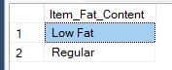

**A. KPI’s**

**1. TOTAL SALES:**

SELECT CAST(SUM(Total_Sales) / 1000000.0 AS DECIMAL(10,2)) AS Total_Sales_Million

FROM blinkit_data;

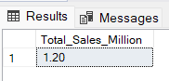

**2. AVERAGE SALES**

SELECT Round(AVG(Total_Sales),2) AS Avg_Sales

FROM blinkit_data;

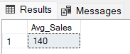

**3. NO. OF ITEMS**

SELECT COUNT(*) AS No_of_Orders

FROM blinkit_data;

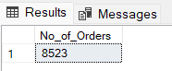

**4. AVG RATING**

SELECT Round(AVG(Rating),2) AS Avg_Rating

FROM blinkit_data;

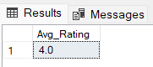

**B. Total Sales by Fat Content:**

select `Item Fat Content`,

cast(sum(`Total Sales`) as decimal(10,2)) as `Total Sales`,

round(avg(`Total Sales`),2) AS AVG_TotalSales,

count(*) as TotalItems,

round(avg(Rating),2) as Rating

from blinkit group by `Item Fat Content`;

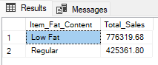

**C. Total Sales by Item Type**

select `Item Type`, Cast(sum(`Total Sales`) as decimal(10,2)) as `Total Sales`,

round(avg(`Total Sales`),2) AS AVG_TotalSales,

count(*) as TotalItems,

round(avg(Rating),2) as Rating

from blinkit group by `Item Type`

Order by `Total Sales` ASC LIMIT 5;

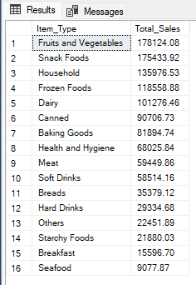

**D. Fat Content by Outlet for Total Sales**

SELECT

`outlet location type`,

ROUND(SUM(CASE WHEN `Item Fat Content` = 'Low Fat' THEN `Total Sales` ELSE 0 END), 2) AS `Low Fat`,

ROUND(SUM (CASE WHEN `Item Fat Content` = 'Regular' THEN `Total Sales` ELSE 0 END), 2) AS `Regular`

FROM

blinkit

GROUP BY

`outlet location type`

ORDER BY

`outlet location type`;

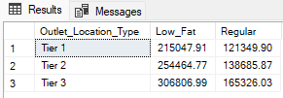

**E. Total Sales by Outlet Establishment**

select `outlet establishment year`,

round(sum(`Total Sales`),2) as `Total Sales` from

blinkit

group by `outlet establishment year`

order by `outlet establishment year`;

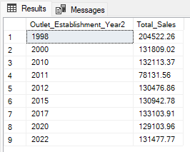

**F. Percentage of Sales by Outlet Size**

select `outlet size`, round(sum(`Total Sales`),2) as `Outlet Total Sales`,

round(sum(`Total Sales`)/(select sum(`total sales`) from blinkit)*100,2) as `Percentage Total`

from blinkit

group by `outlet size`;

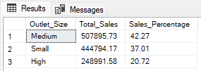

**G. Sales by Outlet Location**

select `outlet Location Type`,

round(sum(`Total Sales`),2) as `Total Sales` from

blinkit

group by `outlet Location Type`;

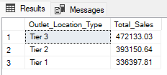

**H. All Metrics by Outlet Type:**

select `outlet type`,

round(sum(`Total Sales`),2) as `Total Sales`,

round(sum(`Total Sales`)/(select sum(`total sales`) from blinkit)*100,2) as `Percentage Total`,

count(*) as TotalItems,

round(avg(`Total Sales`),2) AS AVG_TotalSales,

round(avg(Rating),2) as Rating

from blinkit

group by `outlet type`;

